Multiple-choice section – choose the correct answer

Question 1 [6.1]

What is the value of *s*in the following diagram?

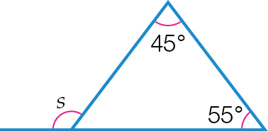

A 135°B 55°C 305°D 100°

Question 2 [6.2]

Which congruence test proves that the given pair of triangles is congruent?

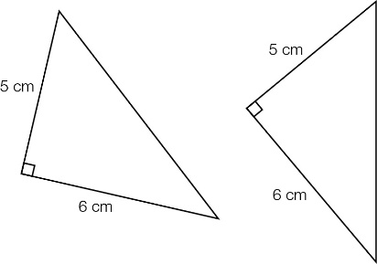

A RHS B SSS C SAS D ASA

Question 3 [6.4]

Rose is enlarging a 4 cm by 3 cm photo to fit onto an A4 page (297 mm by 210 mm). She wishes to use as much of the A4 page as possible. The most appropriate scale factor is:

A 7 B  C 7.5 D 

Question 4 [6.3]

Which of the following best describes a rhombus?

A four right angles, opposite sides equal in length

B one pair of parallel opposite sides

C adjacent sides of equal length, opposite sides parallel

D adjacent sides of equal length, one angle a right angle

Question 5 [6.1]

What is the value of *a* in the following diagram?

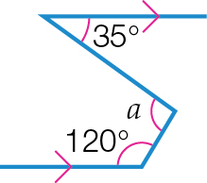

A 95 B 155 C 35 D 180

Question 6 [6.5]

The scale factor of the pair of similar triangles below is:

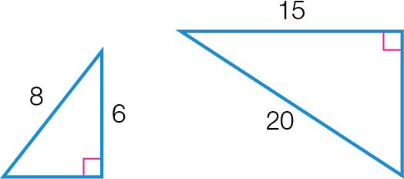

A  **B**  **C**  **D** 

Question 7 [6.1]

Which of the following is *not* correct?

A Vertically opposite angles are equal. B Supplementary angles sum to 90°.

C Polygon angle sum is given by *S* = 180(*n* – 2). D Co-interior angles sum to 90°.

Question 8 [6.3]

The size of an interior angle of a regular octagon is:

**A** 1440° **B** 180° **C** 1080° **D** 540°

Question 9 [6.7]

A solid has a uniform cross-section in the shape of a triangle. The solid is called a:

**A** triangular pyramid **B** square prism **C** triangular prism **D** tetrahedron

Question 10 [6.3]

In a kite, an angle between two sides of different lengths is 94°. Another angle in the kite must be:

**A** 266° **B** 94° **C** 133° **D** 86°

Question 11 [6.4]

∆*ABC* has been reduced to ∆*A′B′C′* using a scale factor of 0.5. If *AB* = 1.6 cm, then *A′B′* is equal to:

**A** 0.8 cm **B** 1.6 cm **C** 2.4 cm **D** 3.2 cm

Question 12 [6.6]

Two similar triangles have heights 6 cm and 10 cm and base lengths 14 cm and *x* cm respectively. The value of *x* is closest to:

**A** 4.3 **B** 8.4 **C** 18.0 **D** 23.3

Multiple-choice results: ___ / 12

Short answer section

Question 13 6 marks [6.3]

Find the value of the pronumerals in the following diagrams.

**(a)**

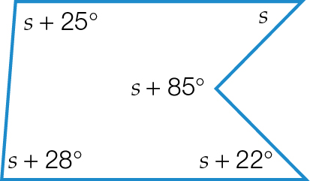

**(b)**

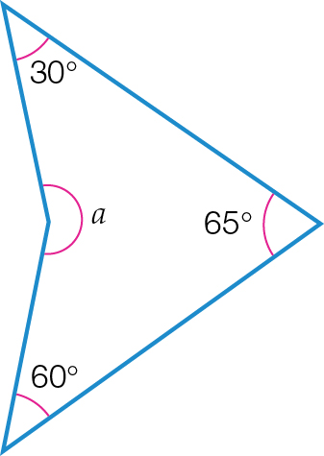

**(c)**

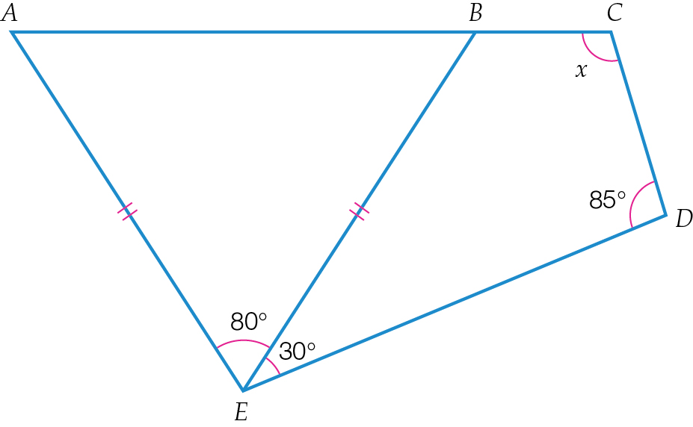

**(d)**

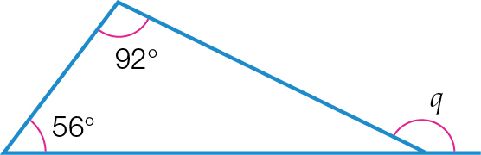

**(e)**

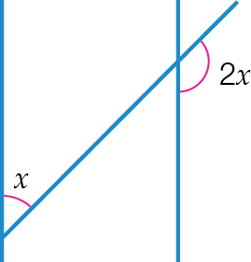

**(f)**

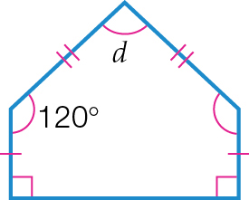

Question 14 4 marks [6.5]

Find the value of the pronumerals in the following diagrams.

**(a)**

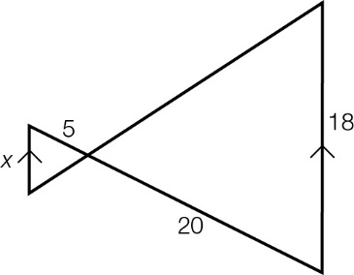

**(b)**

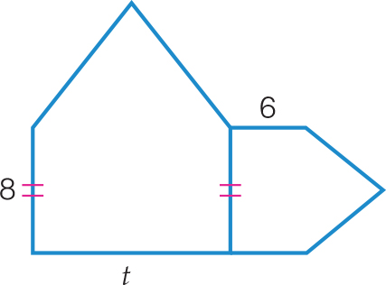

Question 15 3 marks [6.6]

Determine the ratio of the following pairs of triangles and find the value of *y.*

**(a)**

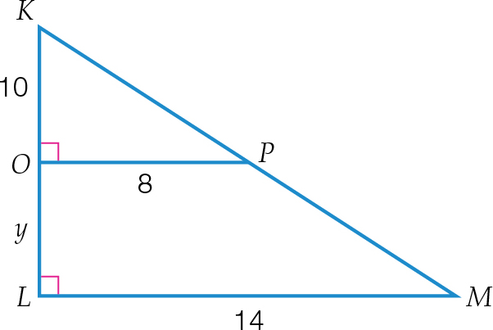

**(b)**

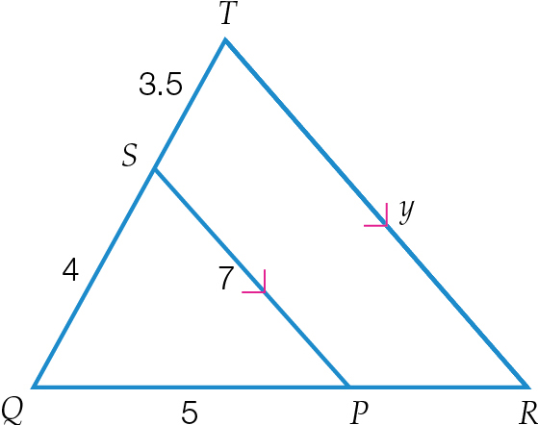

Question 16 3 marks [6.4]

The figures below have the same shape.

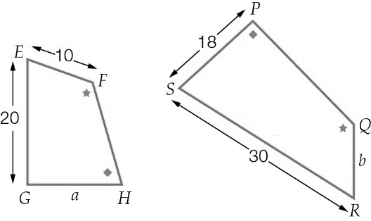

Find the:

**(a)** scale factor of the sides

**(b)** length *a*

**(c)** length *b.*

Question 17 4 marks [6.5]

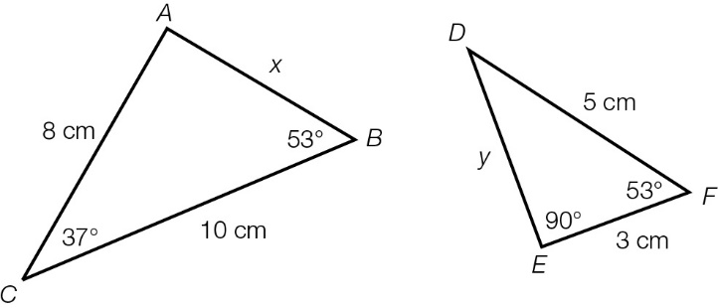

**(a)** Show that the triangles are similar.

**(b)** Hence find the values of *x* and *y*.

Question 18 4 marks [6.5,6.6]

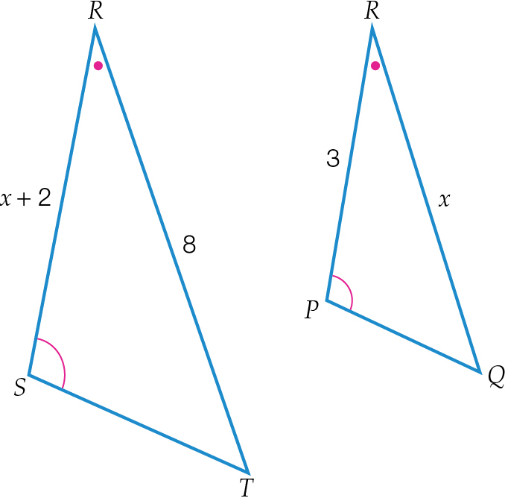

**(a)** Show that the triangles are similar.

**(b)** Hence find the value of *x*.

Question 19 2 marks [6.7]

Draw and label the net of this triangular prism. Show all necessary measurements.

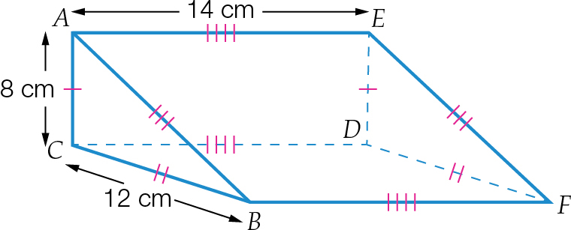

Question 20 1 mark [6.3]

Explain why a square is a rectangle but a rectangle is not necessarily a square.

Question 21 3 marks [6.1]

Find the value of the pronumerals. Give reasons for your answer.

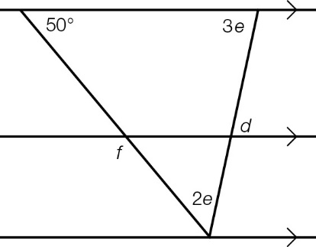

Question 22 4 marks [6.1]

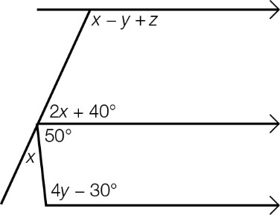

**(a)** Form an equation and solve it to find *x*. Give reasons for your answer.

**(b)** Form an equation and solve it to find *y*. Give reasons for your answer.

**(c)** Hence find the value of *z*.

Question 23 3 marks [6.2]

Prove that ∆*DEH* ≡ ∆*GFH* and then find the value of *x*.

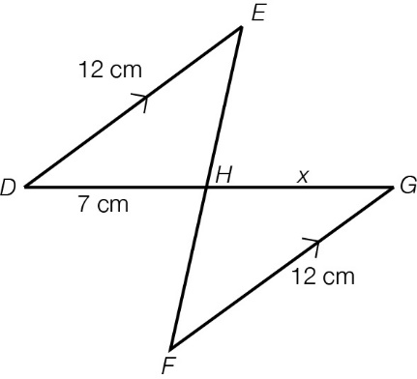

Question 24 3 marks [6.6]

Christy’s dad bounces a ball from his head height and Christy catches it at her head height, as the following diagram shows. If her dad is 2.1 m tall, how tall is Christy?

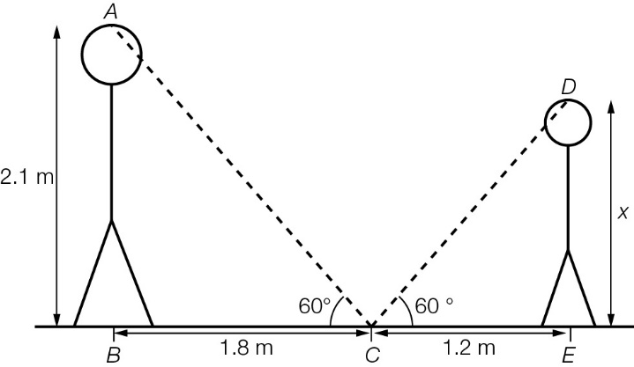

Short answer results: ___ / 40

Extended answer section

Question 25 3 marks [6.3]

Find the number of sides of a polygon that has interior angles of 162°.

Question 26 4 marks [6.6]

Sofia (*S*) can see a tree across the riverbank. She places rocks (dots) on her side of the river to try to calculate the river’s width. She measures the distances between some pairs of rocks and finds that *SQ* = 20 m, *QT* = 5 m and *TR* = 4 m, as shown in the diagram below.

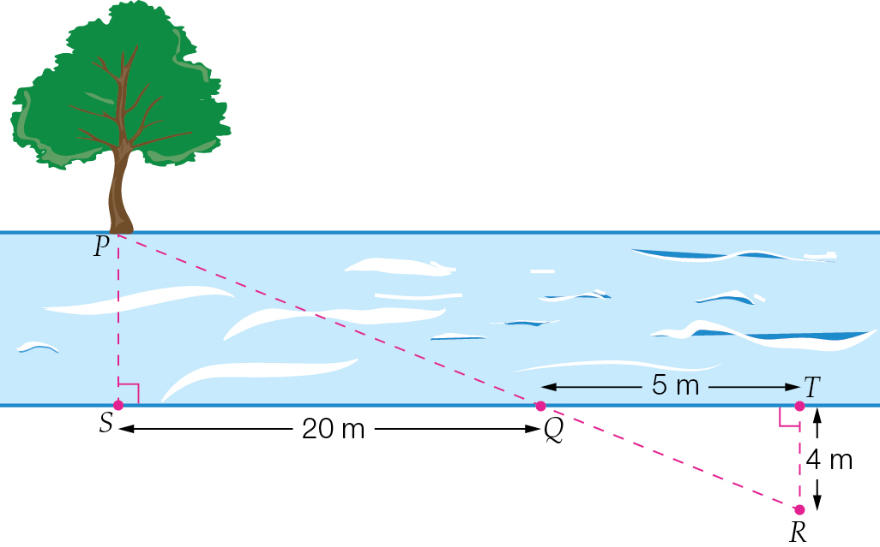

(a) Prove that Sofia has formed a pair of similar triangles ∆*PSQ* ⫼ ∆*RTQ*.

(b) Find the width of the river by calculating the distance *PS*.

Question 27 3 marks [6.5]

∆*ABC* and ∆*KLM* are similar triangles.

∆*ABC* is shown here. ∠*KLM* = 30°, ∠*LKM* = 95°, *LM* = 5 cm

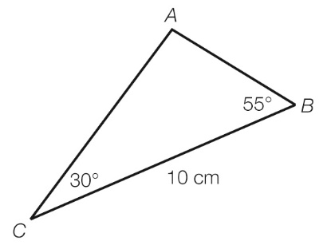

Use this information to:

**(a)** determine the scale factor

**(b)** construct and label ∆*KLM* using a ruler and protractor and the correct scale.

Question 28 2 marks [6.4]

The area of a triangle is 45 cm2. What is the area of this triangle after the dimensions of the triangle have been reduced by a scale factor of ?

Question 29 1 mark [6.3]

An isosceles trapezium is a trapezium with its non-parallel sides equal. Explain how you could easily construct an isosceles trapezium in an isosceles triangle. Show your construction.

Question 30 4 marks [6.6]

In the trapezium *VWXY*, *VW* || *YX*.

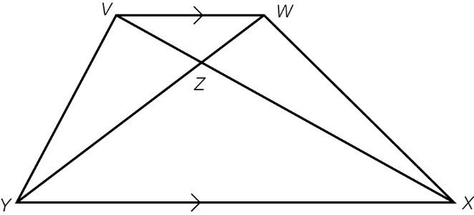

**(a)** Prove that ∆*VWZ* is similar to ∆*XYZ*.

**(b)** Is it possible for ∆*VYZ* ~ ∆*WXZ*?

**(c)** If *VY* = *WX* and ∠*VYX* = ∠*WXY*, prove that ∆*VYX* ≡ ∆*WXY*.

**(d)** Using part **(c)**, explain why ∆*VYZ* ≡ ∆*WXZ*.

Question 31 4 marks [6.6]

In the shape below, ∠*ADE* = ∠*ACB*.

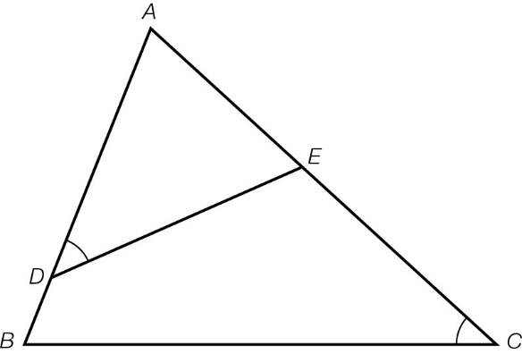

**(a)** Prove that ∆*ABC* is similar to ∆*AED*.

**(b)** Is *DE* parallel to *BC*? Give reasons for your answer.

**(c)** Find the value of ∠*BDE* + ∠*ECB*.

Question 32 3 marks [6.6]

Consider the properties of the following diagram, find the value of the pronumeral and give reasons for your answers. Hint: cut the diagram into triangles.

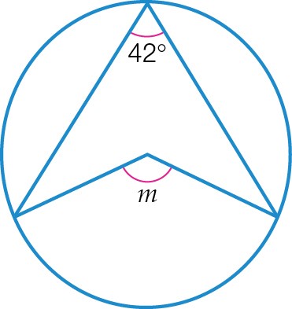

Extended answer results: ___ / 24

TOTAL test results: ___ / 76